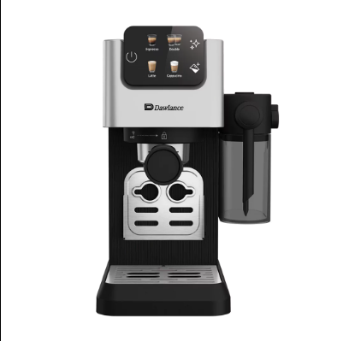

Dawlance Coffee Machine
Rs.49,900
The Dawlance Coffee Machine is a modern espresso maker designed to prepare café-style beverages such as espresso, latte, and cappuccino at home. It features a digital touch control panel, integrated milk container, and powerful brewing system that ensures rich flavor and smooth coffee texture. The machine supports multiple coffee options and allows quick preparation with one-touch operation, making it suitable for both home and office use. This type of model includes 15-bar pressure brewing, which helps extract strong aroma and consistent taste from coffee beans for a professional-quality coffee experience.

Specifications
- Type: Coffee Machine
- Power: 1500–1800 Watts
- Pressure System: 15-bar pump – ensures high-pressure extraction for rich espresso and thick crema.
- Milk Frothing: Integrated 0.3L removable milk reservoir – allows one-touch preparation of cappuccinos and lattes.
- Water Tank: 1.1L removable water tank – easy to refill and clean, suitable for multiple cups.
- Maintenance Features: Automatic descaling and cleaning programs – simplifies maintenance and prolongs machine life.
- Control Interface: Color touch screen display – provides intuitive navigation for selecting coffee types, adjusting settings, and accessing maintenance functions.

Key Features
- One-Touch Coffee Selection
- Integrated Milk Container
- Color Touch Screen Display
- Dual Coffee Outlet
- Cup Warmer Function
- Removable Water Tank
- 15-Bar Brewing Pressure
- Automatic Cleaning Function

